|  |  |  |  |
| --- | --- | --- | --- |
| 1 | | 11,352.0 | |
| NUMERO DE FRONTERAS | | ENERGIA AGREGADA | |
|  | | | |
|  | |  | |
| CONTRATO | | VENCIMIENTO CONTRATO | |
|  | | | |
| 33,438,732 | 101 | | 1,249,937 |
| INGRESO 2019 | DÍAS CERTIFICADOS 2019 | | ENERGIA RESPALDADA 2019 |
|  | | | |
| 34,879,441 | 152 | | 1,200,389 |
| INGRESO 2020 | DÍAS CERTIFICADOS 2020 | | ENERGIA RESPALDADA 2020 |
|  | | | |
| 20,896,799 | 89 | | 922,092 |
| INGRESO 2021 | DÍAS CERTIFICADOS 2021 | | ENERGIA RESPALDADA 2021 |

|  |
| --- |
| **ESTELAR INTERCONTINENTAL**  USUARIO |

|  |
| --- |
| **Mateo Porras**  Ejecutivo de cuenta |

|  |
| --- |
| **Jorge Alfonso Millán Guevara / Gerente Corporativo de Soporte Técnico / jorgea.millan@hotelesestelar.com**  PUNTO FOCAL |

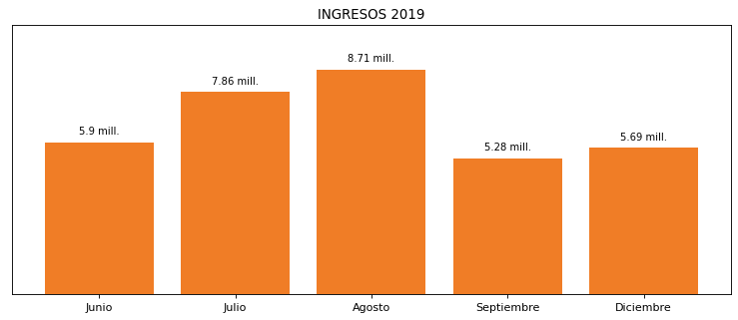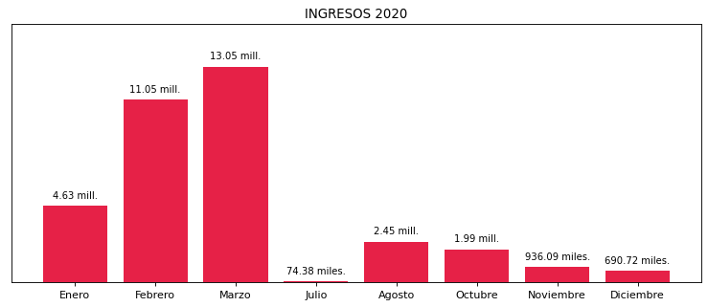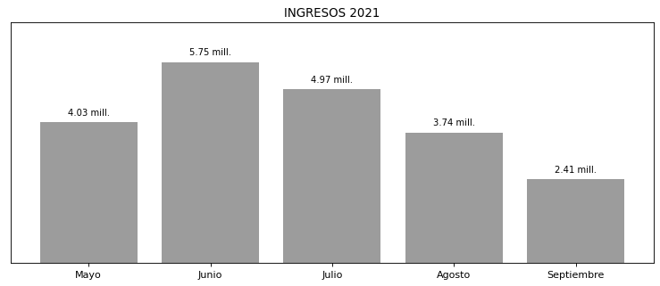

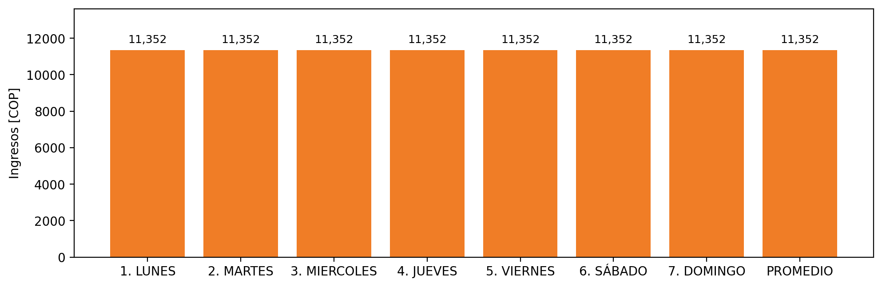

|  |  |  |  |  |  |  |  |  |  |  |
| --- | --- | --- | --- | --- | --- | --- | --- | --- | --- | --- |
| **FRONTERA** | **COD SIC** | **PREDIO** | **FRT DDV** | **TIPO DDV** | **PROMEDIO** | **PRÓXIMA ACTUALIZACIÓN** | **MARGEN DE ERROR** | **ÚLTIMA PRUEBA DDV** | **DÍAS PARTICIPACIÓN** | **FECHA REFERENCIA PRÓXIMA PRUEBA DDV** |
| ESTELAR INTERCONTINENTAL | Frt10951 | Prd01276 | Frt32697 | LBC | 11,352 | 2022-02-23 | 3,29 | 2021-10-04 | 0.0 | 2022-02-14 |